1. **Perform edge detection using Canny Method.**

**Aim:**

To perform edge detection using Canny Method on an image using python.

**Code:**

import cv2

import numpy as np

img = cv2.imread(r"C:\Users\prith\Documents\CV\cvimage.jpg")

cv2.imshow('Original', img)

cv2.waitKey(0)

img_gray = cv2.cvtColor(img, cv2.COLOR_BGR2GRAY)

img_blur = cv2.GaussianBlur(img_gray, (3,3), 0)

sobelx = cv2.Sobel(src=img_blur, ddepth=cv2.CV_64F, dx=1, dy=0, ksize=5)

sobelx = cv2.convertScaleAbs(sobelx)

cv2.imshow('Sobel X', sobelx)

cv2.waitKey(0)

cv2.destroyAllWindows()

**Input:**

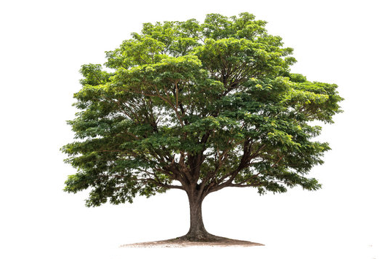

**Output:**

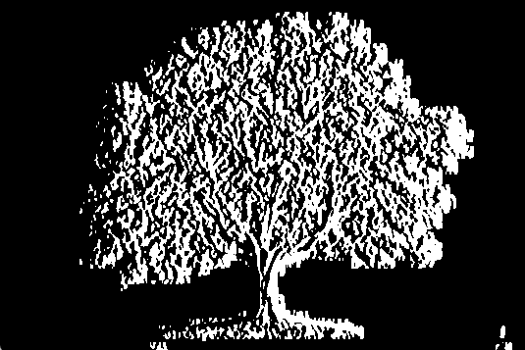

**Result:**

The python code to perform edge detection using Canny Method on an image has been executed successfully.